“САВЫТ – САБА”

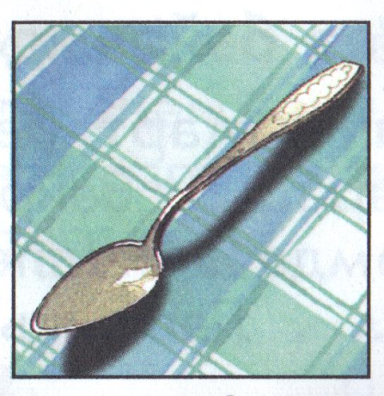 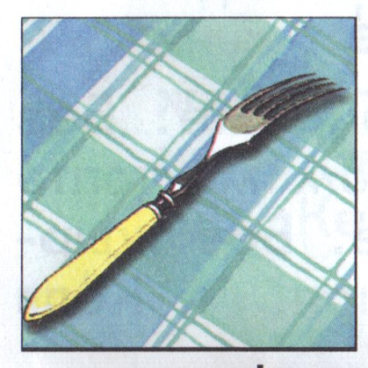 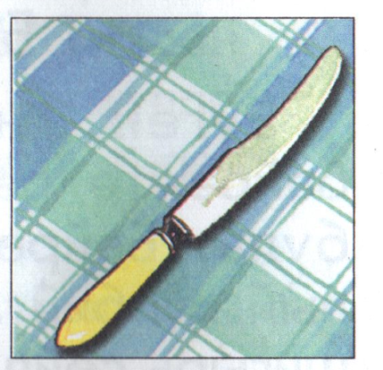 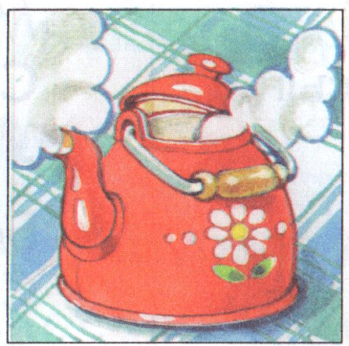

|  |  |  |
| --- | --- | --- |
|  |  |  |

|  |  |  |  |  |  |  |  |  |
| --- | --- | --- | --- | --- | --- | --- | --- | --- |
|  | К |  |  |  |  |  |  |  |
|  | П |  |  |  |  |  |  |  |
|  | Ч |  |  |  |  |  |  |  |
|  | Ч |  |  |  |  |  |  |  |
|  | Т |  |  |  |  |  |  |  |
|  | Ч |  |  |  |  |  |  |  |

