“ЯШЕЛЧӘЛӘР”

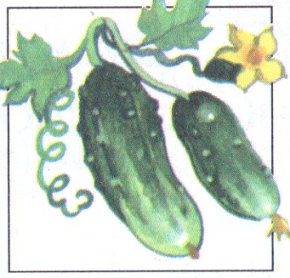 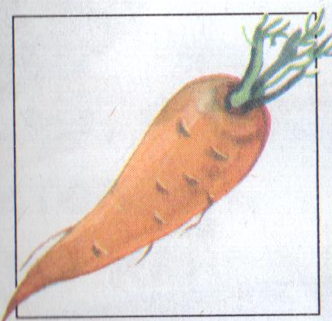 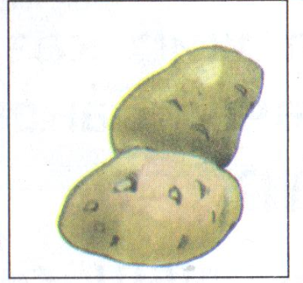

|  |  |  |  |  |  |  |  |  |
| --- | --- | --- | --- | --- | --- | --- | --- | --- |
|  |  |  |  |  |  |  |  |  |
|  | к |  |  |  |  |  |  |  |
|  | к |  |  |  |  |  |  |  |
|  | к |  |  |  |  |  |  |  |
|  | с |  |  |  |  |  |  |  |
|  | ш |  |  |  |  |  |  |  |
|  | к |  |  |  |  |  |  |  |
|  | б |  |  |  |  |  |  |  |
|  | п |  |  |  |  |  |  |  |
|  |  |  |  |  |  |  |  |  |

